1. Answer the following questions about regular binary search trees and AVL trees.
2. Show the final result when you insert items with the following keys into an initially empty regular binary search tree (not an AVL tree): 31, 41, 59, 26, 53, 58, 97, 93, 23, 84, 62 (in that order).

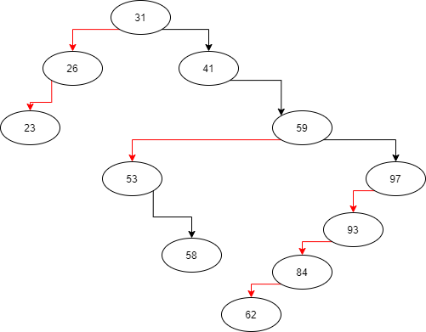

1. For the result of part (a), show the results of a preorder traversal, a postorder traversal, an inorder traversal, and a breadth-first search.

* preorder traversal: 31, 26, 23, 41, 59,53,58, 97,93, 84, 62
* postorder traversal: 23, 26, 58, 53, 97, 93, 84, 62, 59, 41, 31
* inorder traversal: 23, 26, 31, 41, 53, 58, 59, 62, 84, 93, 97

1. Show the result *after each insertion* when you insert items with the following keys into an initially empty AVL tree: 31, 41, 59, 26, 53, 58, 97, 93, 23, 84, 62 (in that order).

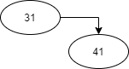

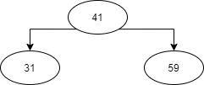

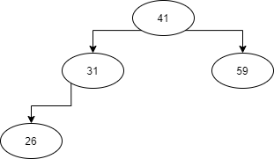

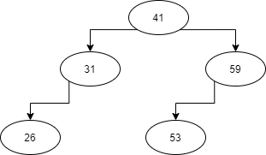

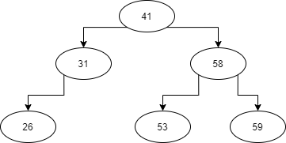

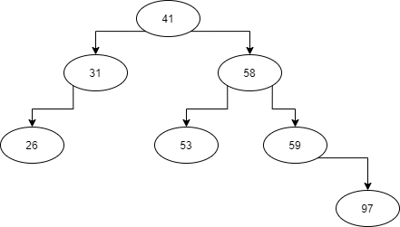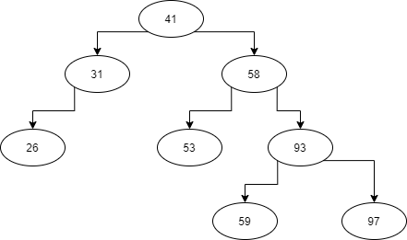

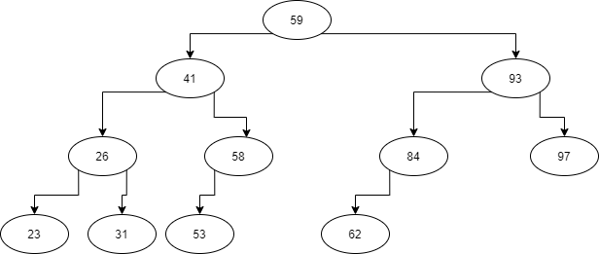

1. Briefly answer the following questions about sorting algorithms and selection algorithms that were discussed in the course.
2. Consider typical implementations of each of the following sorts. Indicate all that are stable: bubble sort, selection sort, insertion sort, mergesort, quicksort.

|  |  |
| --- | --- |
| bubble sort | Yes |
| selection sort | No |
| insertion sort | Yes |
| mergesort | Yes |
| quicksort | No |

1. Consider sorting a large array (meaning there are many elements) of very large objects (meaning each object occupies a lot of memory), such that the entire sequence exists in main memory. It is therefore important to use a sort with a good complexity but also to minimize swaps of the large objects. What strategy did we discuss that can be useful for such a scenario? (You don't have to explain it; what is the word or phrase.)

**Indirect Sorting**

1. Database management systems often have to sort data existing on an external memory device that may be too big to exist in main memory. What general strategy did we discuss that can be useful for such a scenario? (You don't have to explain it; what is the word or phrase.)

**External Sorting**

1. Assume that least-significant-digit radix sort, as discussed in class, is used to sort an array of N 32-bit integers using 256 bins. How many passes are needed? What is the worst-case complexity of the sort? What is the average-case complexity of the sort?

* 4 passes
* Worse: O(N)
* Average: O(N)

1. Consider the quickselect algorithm discussed in class. We first discussed it assuming that a typical algorithm is used for choosing the pivot, such as median-of-three pivot selection. We then discussed a version of quickselect using a pivot selection algorithm that our textbook calls median-of-median-of-five. What is the main advantage of using median-of-median-of-five partitioning for quickselect? Why isn't it used more often?

* Although it has a worst-case linear quickselect routine, on average, in terms of real time, the average case quickselect with a typical pivot selection routine will be faster.